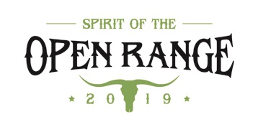

Invitation To
Name _______________________________________________________

INTERNATIONAL OPEN MATCH OF COWBOY SHOOTING
Date: September 28th - 29th, 2019

Shooting Range: Raguvos šaudykla (55°06'55.6"N 24°47'14.3"E), Tel.: (370-608) 20532
Participant of this match, must bring to Lithuania his/her own guns and ammunition according to SASS rules. Specifically:
• Single action cartridge revolvers and/or caps and balls revolvers, caliber 32 or larger.
• Lever action and/or slide action rifles 32 cal. or larger.
• Single shot rifles with external hammer.
• Side by side, slide action or lever action shotguns
• Sufficient amount ammunition in relevant calibers
• As well as additional weapons for back-up or for the side matches.
Please bring your appropriate equipment and the weapons that you own with you when you travel in Italy.
We are looking forward to welcome you on the range!

Match Director: Saulius Navickas aka Stampi (+370 698 333 22).

